QR CODE HERE

Variations of the Hymen

Draft: November 2023

About this leaflet

This information leaflet is for young people and/or their parents/caregivers who have been diagnosed with, or think they may have, an variation of the hymen. Your healthcare team will further support you in deciding about your care and what is right for you, answering any questions that you may have.

Key points

- Variation in appearance of the hymen are common. They come in all different shapes, thickness and sizes and often do not need correction
- Variations of the hymen requiring treatment are rare
- An imperforate hymen causes a complete obstruction of period blood
- A microperforate, cribriform or septate hymen form a partial obstruction at the entrance to the vagina
- A microperforate, cribriform or septate hymen can cause problems with tampon use or sexual intercourse
- Surgery can be used if there is an obstruction caused by a variation of the hymen

What is the hymen?

The hymen is a thin area of skin-like tissue at the opening to the vagina. The hymen needs to be open to allow period blood to leave the vagina.

There can be different appearances and types, and the common differences are discussed here.

What is an imperforate hymen?

An imperforate hymen completely covers the entrance to the vagina.

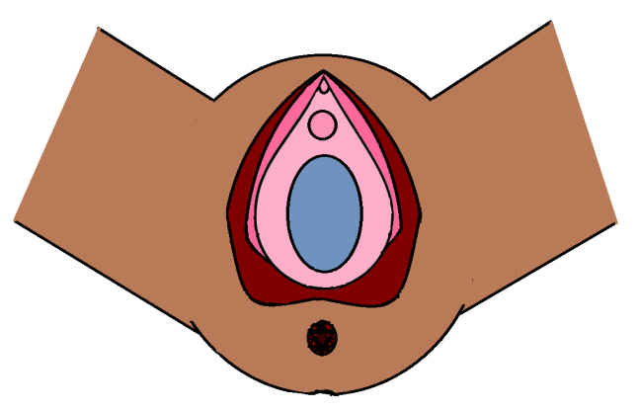
Imperforate hymen

What are the symptoms of an imperforate hymen?

Imperforate hymen can sometimes be diagnosed in a newborn baby when a bulge behind it may be noticeable behind it. This is caused by a build up of mucus secretions under the influence of hormones from the mother.

You may have started your periods, but you don’t see the blood because it is trapped behind the hymen in the vagina. You might feel cramps at the time of your period, but you may not be aware that this is the cause of the pain.

You might be aware of a bulging area on the vulva, which is the blocked period. This may give you tummy or back pain. You may have problems passing urine or pass urine very frequently.

You may have noticed that you are not able to easily insert a tampon, or not able to insert a tampon. You may have the same challenges with vaginal sexual intercourse. .

What do the terms microperforate, cribriform and septate hymen mean?

These terms are used when when the membrane partially covers the vagina.

- a microperforate hymen has only a small opening in the hymen.
- a cribriform hymen may have multiple small openings.
- a septate hymen has a band of tissue dividing the vaginal opening into 2 parts.

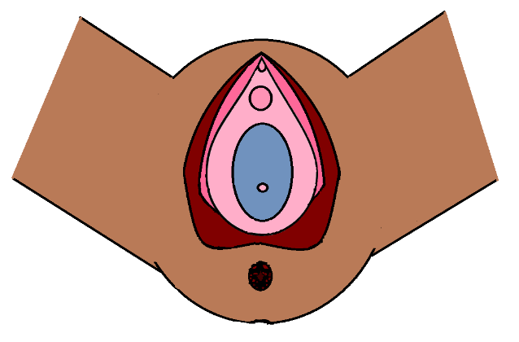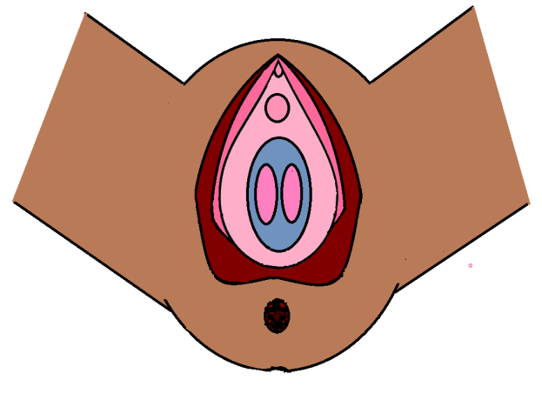
Microperforate hymen
Septate hymen

Cribriform hymen

What are the symptoms of a microperforate or cribriform hymen?

You will normally have periods, but it is unlikely you would be able to insert a tampon or have sexual intercourse as the opening in the hymen is usually quite small.

A microperforate hymen may make the free flow of period blood difficult and you may have spotting for prolonged period of time.

What are the symptoms of a septate hymen?

You will normally have periods, but you may have difficulties with either inserted or removing tampons as they catches on the hymenal tissue. It is important that tampons are always removed after use to prevent infection developing. If you are having difficultly removing a tampon then please seek advice from your GP or NHS 111.

What causes these differences to occur?

The hymen is present when you are in the womb as part of the normal development of the vagina. Usually it dissolves by birth but sometimes this does not occur, leading to some or all of the hymen being left behind. Hymenal anomalies are rare, with an incidence of 0.05 - 0.1%. They do not run in families. They are not associated with and long term issues with fertility or childbirth.

Will I need any tests?

You will be offered a gentle external examination to confirm whether there is a variation of the hymen . Your doctor may arrange an ultrasound to check for trapped blood and to look at the womb and ovaries. Changes to the hymen are not associated with other differences in anatomy.

Treatment

Imperforate / microperforate / cribriform hymen

If the variation is diagnosed as a baby or young child then treatment can be delayed until puberty.

Opening the hymen or removing the excess hymen surgically is recommended. This is done under a general anaesthetic and is normally a day procedure. The stitches used are dissolvable.

For an imperforate hymen surgery should be done soon to avoid problems and pain due to the blocked periods. Some girls may be offered hormone medication to suppress the periods whilst an operation is being arranged.

What can I expect after the operation?

You may experience a little discomfort and light bleeding for a few days after the operation as healing occurs.

You can get back to regular activities as soon as you feel comfortable. You can bath and shower as usual, although avoid soaps and shower gel on the area.

By removing the hymen it allows the blood from your periods to drain out. It also means you can use tampons and have vaginal sexual intercourse. We advise waiting two weeks before putting anything like a tampon sides the vagina. This will reduce the risk of infection.

What happens if an imperforate hymen isn’t treated?

There is a risk of infections going up into the womb as the blood and vaginal fluid cannot drain from the vagina. This can lead to pain and difficulty in passing urine.

Septate hymen

The bridge of hymen tissue can be removed surgically. This can be done under a general anaesthetic or with local anaesthetic in an outpatients setting. The sutures (stitches) used are dissolvable.

What happens if microperforate or septate hymen isn’t treated?

It will continue to be problematic inserting or removing tampons or may tear during attempted sexual intercourse leading to bleeding..

Are there any possible complications from the surgery?

All operations carry a risk of narrowing due to scar formation, infection, or bruising. For this reason, the operations should be performed by a clinician trained to perform these procedures.

Further information

These resources are for information only and are not meant to be comprehensive. Referral to these resources does not imply endorsement of the organisation, the organisation's website, or the content of the resource. The resources may change without notice.

https://patient.info/news-and-features/common-myths-about-the-hymen-debunked

https://www.bbc.co.uk/bbcthree/article/295423a4-dbd4-4277-af2c-7843f794eb7f

